GRADE 7 ACCELERATED · UNIT 1 · LESSON 1
Rewriting Numbers in Equivalent Forms
Teacher's Edition
Standard and Targets
MA.7.NSO.1.2 Rewrite rational numbers in different but equivalent forms including fractions, mixed numbers, repeating decimals and percentages to solve mathematical and real-world problems.
Learning target I can write a rational number as a fraction, a decimal or a percentage, and use bar notation when the decimal repeats.
Essential questions How can I rewrite rational numbers in different but equivalent forms? What are repeating decimals, and which fractions have decimal expansions that repeat?
Building on MA.6.NSO.3.5 — rewriting positive rational numbers in equivalent forms, terminating decimals only. Repeating decimals are new here.
Working toward MA.8.NSO.1.1 — defining irrational numbers within the real number system. An irrational number is exactly the decimal that neither terminates nor repeats, so it cannot be defined until today's two categories exist.
Where this sits in the course MA.7.NSO.1.2 is required content of course 1205050, and your students have not taken grade 7 mathematics. This is first-time learning, not review — they are meeting these three forms for the first time in the same year they sit the Grade 8 FAST. The code itself is not one the FAST reports; that blueprint is written entirely in MA.8 codes. But that is a fact about the score report, not about what the test asks. Converting between fractions, decimals and percents sits inside MA.8.NSO.1.1 — the heaviest reporting category on the exam — and inside every rate, percent, proportion and slope item in the year ahead. Teach it to fluency.
Materials Whiteboards and markers. TI-30XA calculators, one per student. Worksheet 7A.01.01. Desmos scientific projected, if you have it — slides 13–15 is better with it.
Lesson at a Glance
Windy Hill periods run 53 minutes.
Segment | Slides | Time
Settle in; post the learning target | 1 | 1 min
Warm-Up: which fractions never stop? | 2 | 4 min
Notes I–IV: rational numbers, the bar, simplify first, watch the remainders | 3–6 | 12 min
Example 1: the fraction table, then bar notation | 7–9 | 5 min
Example 2: the pattern in ninths | 10–12 | 5 min
Example 3: what the calculator does not tell you | 13–15 | 4 min
Whiteboards: 9 questions, each with its reveal | 16–33 | 17 min
IXL — start today's skills | 34 | 5 min
Total |  | 53 min

Where the lesson lives: Slides 13–15. It is the only place the calculator's rounding gets named, and every table in this lesson is built on calculator output. Cutting it leaves students believing 5/9 ends in a 6.
No partner or group work anywhere in this lesson. Math Nation's version has eight separate collaboration prompts: the Refresher matching activity, the Guided Instruction pattern discussion, three prompts in the Exploration, and Think-Pair-Share named twice in the Bring It Together notes plus once in the Refresher tips. All of it is now individual — the matching activity is Notes III, the Exploration is Example 2 with students working alone and you pooling at the board, and the Think-Pair-Shares are the whiteboard sequence.
Vocabulary

rational number — a number that can be written as a ratio of two integers
terminating decimal — a decimal that stops
repeating decimal — a decimal that never stops, but repeats a pattern forever
bar notation — a bar drawn over the digits that repeat
Two notes on the glossary. Math Nation lists “rational number” and “repeating decimal” as key terms and “terminating” and “ellipse” as additional terms. “Bar notation” is not on their list even though the whole lesson depends on it, so it is treated as a term here. And their word ellipse is wrong — an ellipse is an oval. The three dots are an ellipsis. It has been corrected everywhere in these materials.
Slide-by-Slide Teaching Notes
Slide 1. Rewriting Numbers in Equivalent Forms 1 min
- Post the learning target and say the framing sentence out loud: every decimal either stops or repeats, and today we learn to tell which.
- That sentence is the whole lesson, and in Unit 2 Lesson 4 it becomes the definition of an irrational number — the decimal that does neither.
- This benchmark is grade 7 content carried by the accelerated course; it is not itself on the Grade 8 FAST, but MA.8.NSO.1.1 is unanswerable without it.
Slide 2. Warm-Up 4 min
- TYPE: Reflect, expect, check, explain.
- INDEPENDENT.
- ANSWERS: 1/3 and 1/6 never stop. 1/2 = 0.5, 1/5 = 0.2 and 3/8 = 0.375 all stop. Take three different explanations before confirming anything — the reasoning is the point. Likely student reasons: 'thirds are the ones that don't come out even'; 'you can make halves, fifths and eighths into hundredths but not thirds'; 'I remember 1/3 = 0.333'. Any of those is a good start. Do NOT give the rule here; it is built across Notes III and IV. This replaces Math Nation's career-profile video and its two reflection questions, which contained no mathematics.
- OFF THE SLIDE, YOURS TO SAY: A guess with a reason is worth more here than an answer with none.
Slide 3. Notes: I. Every rational number's decimal stops or repeats 3 min
- Students copy all four lines.
- Point at the fraction bar and say it aloud: the bar means divide.
- Item D is the sentence Unit 2 will break — an irrational number is a decimal that neither stops nor repeats, and it is not rational at all.
- Do not say that yet, but know that is where it is going.
- OFF THE SLIDE, YOURS TO SAY: To change a fraction to a decimal, divide the top by the bottom.
Slide 4. Notes: II. The bar covers the repeating digits only 3 min
- Say the bar aloud as 'repeats forever'.
- The third line is the one to slow down on: only the 6 repeats in 2.1666…, so the bar sits on the 6 and not on the 1.
- That is worksheet question 6, where a bar over 86 and a bar over 6 are both offered.
- Also correct the book here: Math Nation's student edition calls the three dots an 'ellipse'.
- An ellipse is an oval.
- The three dots are an ellipsis.
- OFF THE SLIDE, YOURS TO SAY: In 2.1666… the bar goes over the 6 alone. The 1 does not repeat.
Slide 5. Notes: III. Simplify first — the denominator lies until you do 3 min
- This is the trap, and it is worth its own slide.
- Write 6/15 on the board and ask for a prediction before anyone simplifies it — most classes say it repeats, because 15 is not a 'nice' denominator.
- Then simplify and divide.
- The point is not the answer; it is that they answered a question about a number they had not finished writing down.
- OFF THE SLIDE, YOURS TO SAY: This is the trap in the Ticket Out the Door. Every fraction on the worksheet is already simplified.
Slide 6. Notes: IV. Divide, and watch the remainders 3 min
- Items A and B are the actual reason, and they are worth 30 seconds of long division at the board: divide 1 by 3 and show the remainder 1 coming back; divide 1 by 8 and show the remainder reaching 0.
- Item C is deliberately NOT a rule — Math Nation holds the rule for Lesson 2 and their teacher's edition says a rule that always works is not expected today.
- Say that out loud so nobody memorizes the list as law, and point at the 15 as you say it: 28/15 repeated and 6/15 stopped, which is the same denominator on both sides of the list.
- Do NOT let 12 onto the board — the Ticket Out the Door is 9/12, it stops, and a student who has written 12 down as a repeating denominator will get it wrong for a reason you gave them.
- OFF THE SLIDE, YOURS TO SAY: That last line is a list of what we saw today, not a rule. We test it in Lesson 2.
Slide 7. Example 1 2 of the 5 min
- Whiteboards, both columns, nothing revealed.
- Three of the five are greater than 1 — watch for students who divide the wrong way round and get a number under 1 for 13/6.
Slide 8. Example 1 2 of the 5 min
- Fill the grid as they call it out.
- Ask for the mixed number on the three that exceed 1: 2 1/6, 4 2/9, 3 2/5.
- This is Math Nation's guided instruction, done as a whole class instead of in partners.
Slide 9. Example 1 1 of the 5 min
- Do the two hardest ones only. 4.222… and 0.375 and 3.4 are quick to check verbally.
- The panel is the standard both assessment keys apply: a repeating decimal written without the bar does not earn the row.
- Say that once, here, and then hold to it.
- OFF THE SLIDE, YOURS TO SAY: Bar notation is not optional on a repeating answer. The ellipsis alone is not exact.
Slide 10. Example 2 2 of the 5 min
- INDEPENDENT, left column only.
- Give them two minutes.
- The right column is covered until the pattern has been said out loud — predicting is the whole point and it is worthless if the answer is already on the board.
Slide 11. Example 2 1 of the 5 min
- Pool the left column at the board and let a student say the pattern.
- Two of these rows will look wrong on a calculator — that is Example 3, and it is coming, so do not resolve it here if somebody raises it.
Slide 12. Example 2 2 of the 5 min
- Ask for the pattern before anyone reaches for anything.
- The two mixed numbers are the ones worth the time: the 3 and the 17 do not change, and students who try to involve them produce answers like 3.555… Ask why 3 2/9 is 3.222… by rule and not by accident — the 3 is untouched and the 2/9 is the ninths pattern.
- OFF THE SLIDE, YOURS TO SAY: The whole-number part comes along unchanged. Only the fraction part becomes the repeating decimal.
Slide 13. Example 3 1 of the 4 min
- Take a vote.
- Most classes say the calculator must be right.
- Do not resolve it — the disagreement is what makes the next slide land.
Slide 14. Example 3 2 of the 4 min
- Say it plainly: the calculator is not lying, it is running out of room and rounding what it cannot show.
- Have them divide 2 by 3 as well — the screen ends in 7 for the same reason.
- Once they have seen it twice it stops being a surprise.
- OFF THE SLIDE, YOURS TO SAY: The 6 on the screen is not part of the number.
Slide 15. Example 3 1 of the 4 min
- Worth thirty seconds because students will meet the disagreement on their own phones.
- The bar notation from Notes II is the only exact way to write the number, which is a good reason for insisting on it rather than an arbitrary one.
- OFF THE SLIDE, YOURS TO SAY: Two tools, two different last digits, and neither is broken. The exact value is the one with the bar over it, and no screen can show it.
Slide 16. Whiteboards · Question 1 of 9 — ask about 20 seconds of thinking
- Boards down until the cue, all up together, scan the back row first, and question a blank board before a wrong one.
- Do not reveal until every board is up.
Slide 17. Whiteboards · Question 1 of 9 — reveal about 1 minute with the discussion
- The baseline.
- Everything after this changes exactly one thing about it.
- COLOR: none on this sequence. One expression and its answer is not two objects and not two slots in a formula, so under rule 5 there is no axis to name and the answer color does the whole job.
Slide 18. Whiteboards · Question 2 of 9 — ask about 20 seconds of thinking
- Boards down until the cue, all up together, scan the back row first, and question a blank board before a wrong one.
- Do not reveal until every board is up.
Slide 19. Whiteboards · Question 2 of 9 — reveal about 1 minute with the discussion
- One feature changed: the form asked for, not the number.
- Same 3/8.
- Boards saying 0.375% moved the point the wrong way, and boards saying 3.75% moved it one place instead of two.
- COLOR: none on this sequence. One expression and its answer is not two objects and not two slots in a formula, so under rule 5 there is no axis to name and the answer color does the whole job.
Slide 20. Whiteboards · Question 3 of 9 — ask about 20 seconds of thinking
- Boards down until the cue, all up together, scan the back row first, and question a blank board before a wrong one.
- Do not reveal until every board is up.
Slide 21. Whiteboards · Question 3 of 9 — reveal about 1 minute with the discussion
- One feature changed: the denominator, 8 to 9.
- That single digit moves the answer across the boundary from Notes I — it stops being a decimal that stops.
- Ask for the bar notation as well.
- COLOR: none on this sequence. One expression and its answer is not two objects and not two slots in a formula, so under rule 5 there is no axis to name and the answer color does the whole job.
Slide 22. Whiteboards · Question 4 of 9 — ask about 20 seconds of thinking
- Boards down until the cue, all up together, scan the back row first, and question a blank board before a wrong one.
- Do not reveal until every board is up.
Slide 23. Whiteboards · Question 4 of 9 — reveal about 1 minute with the discussion
- One feature changed: back to the percent question, on the repeating one.
- The repeat does not go away when you multiply by 100 — it moves.
- A board saying 33% has rounded without being asked to, and a board saying 33.3% has rounded to one place.
- COLOR: none on this sequence. One expression and its answer is not two objects and not two slots in a formula, so under rule 5 there is no axis to name and the answer color does the whole job.
Slide 24. Whiteboards · Question 5 of 9 — ask about 20 seconds of thinking
- Boards down until the cue, all up together, scan the back row first, and question a blank board before a wrong one.
- Do not reveal until every board is up.
Slide 25. Whiteboards · Question 5 of 9 — reveal about 1 minute with the discussion
- One feature changed: the numerator.
- This is Example 2's pattern with a slide of distance on it, and it should now take three seconds rather than a division.
- COLOR: none on this sequence. One expression and its answer is not two objects and not two slots in a formula, so under rule 5 there is no axis to name and the answer color does the whole job.
Slide 26. Whiteboards · Question 6 of 9 — ask about 20 seconds of thinking
- Boards down until the cue, all up together, scan the back row first, and question a blank board before a wrong one.
- Do not reveal until every board is up.
Slide 27. Whiteboards · Question 6 of 9 — reveal about 1 minute with the discussion
- THE ONE THAT EARNS ITS PLACE.
- One feature changed: the direction.
- Every question so far started from the fraction — three of them asked for a decimal and two for a percent; this one starts from the decimal and asks for the fraction.
- A student who has the pattern answers instantly; a student who memorized five separate results has nothing to work with.
- Close by asking what 0.888… would be, and then 0.999…, which Lesson 2 settles at whiteboard question 5.
- COLOR: none on this sequence. One expression and its answer is not two objects and not two slots in a formula, so under rule 5 there is no axis to name and the answer color does the whole job.
Slide 28. Whiteboards · Question 7 of 9 — ask about 20 seconds of thinking
- Boards down until the cue, all up together, scan the back row first, and question a blank board before a wrong one.
- Do not reveal until every board is up.
Slide 29. Whiteboards · Question 7 of 9 — reveal about 1 minute with the discussion
- One feature changed: the repeat no longer starts at the decimal point.
- Every repeating decimal so far began repeating immediately — 0.333…, 0.555…, 0.777… — so a bar over everything after the point was always right by accident.
- Here it is wrong.
- THE TWO BOARDS TO LOOK FOR, each a named error: a bar over 86 has started one digit early and claims 1.868686…, which is a different number; a bar over the whole of 1.86 claims the 1 repeats as well.
- Both are the same misreading — that the bar marks everything after the point rather than the digits that actually recur.
- This is 28/15, and it is on the worksheet bank as its question 6.
- COLOR: none on this sequence. One expression and its answer is not two objects and not two slots in a formula, so under rule 5 there is no axis to name and the answer color does the whole job.
Slide 30. Whiteboards · Question 8 of 9 — ask about 20 seconds of thinking
- Boards down until the cue, all up together, scan the back row first, and question a blank board before a wrong one.
- Do not reveal until every board is up.
Slide 31. Whiteboards · Question 8 of 9 — reveal about 1 minute with the discussion
- One feature changed: the question is now about which, not what — a classification rather than a conversion, and the FAST asks it this way. 7/20 = 0.35 and 9/8 = 1.125 stop; 5/12 = 0.41666… and 4/15 = 0.2666… do not.
- THE BOARD TO LOOK FOR PICKS 5/12, and the reason is worth taking aloud: the student has spotted that 12 is even and decided even denominators stop.
- It is a real pattern that fails, and the repair is Notes I — break the denominator into factors and look for anything that is not a 2 or a 5.
- Twelve carries a 3, and so does fifteen.
- A student who divides all four out instead is not wrong, just slow; say so, and say what the factors would have told them in five seconds.
- COLOR: none on this sequence. One expression and its answer is not two objects and not two slots in a formula, so under rule 5 there is no axis to name and the answer color does the whole job.
Slide 32. Whiteboards · Question 9 of 9 — ask about 90 seconds of writing
- Boards down until the cue, all up together, scan the back row first, and question a blank board before a wrong one.
- Do not reveal until every board is up.
Slide 33. Whiteboards · Question 9 of 9 — reveal about 2 minutes with the closing discussion
- WRITTEN WORK, and the only question in the round that asks for it.
- With the worksheet gone this is the only place in the period the habit gets built, and IXL takes an answer without ever seeing the work.
- ANSWER: no. 3 ÷ 8 = 0.375, which is not 0.38.
- ANA'S ERROR HAS A NAME and it is the one to draw out: she read the digits of the fraction off and put a point in front of them, which is question 1 of the worksheet bank — the strategy that looks like it always works and does not.
- It happens to be close here, 0.375 against 0.38, and that is exactly why it survives; ask what it would give for 3/80.
- What earns the mark is the division, written down. "No, it is 0.375" with no working is the right answer to a question that asked for more than the answer.
- COLOR: none on this sequence. One expression and its answer is not two objects and not two slots in a formula, so under rule 5 there is no axis to name and the answer color does the whole job.
Slide 34. IXL 5 min
- IXL.
- The skills are assigned in Google Classroom, not named here, and they are deliberately not ours -- Croix: "The students need questions that aren't exclusively mine.
- Makes them think." Circulate.
- The thing to watch for is a student answering in the box with no paper in front of them: IXL takes an answer and never sees the work, so this is the one part of the period where the habit can quietly lapse.
Worksheet 7A.01.01 — Answer Key
1. which strategy always works | Divide the numerator by the denominator.  The other two fraction strategies work sometimes. A denominator of 100 works for 17/20 but not for 1/3, because no whole number times 3 is 100. Multiplying or dividing by 100 converts decimals and percentages.
2. which strategy always works | Use the place value of the last digit to determine the denominator.  In 0.85 the last digit is in the hundredths place, so the fraction is 85/100 = 17/20.
3. 5/6 | 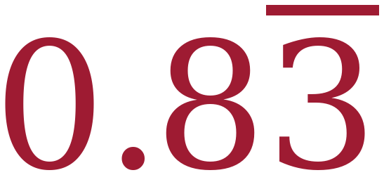 repeating  5 ÷ 6 = 0.8333… The 8 does not repeat; only the 3 does.
4. 17/8 | 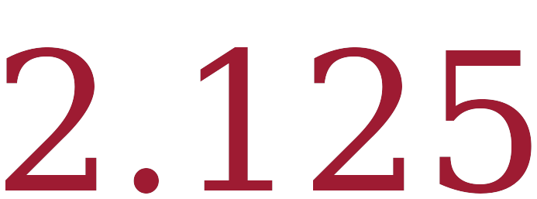 terminating  17 ÷ 8 = 2.125 exactly.
5. 14/3 | 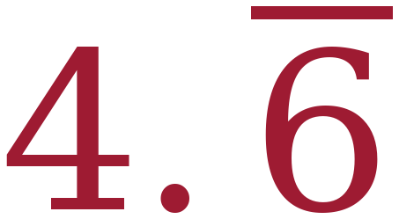 repeating  14 ÷ 3 = 4.666…
6. bar notation | C. 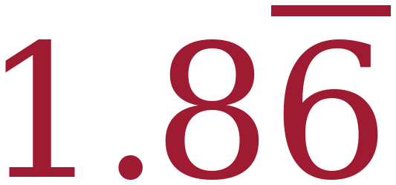  28/15 = 1.8666… so only the 6 repeats. B would be 1.868686…, D is 1.86 exactly, and A bars the whole number, which bar notation never does.
7. 1/9 |   1 ÷ 9 = 0.111…
8. 5 4/9 | 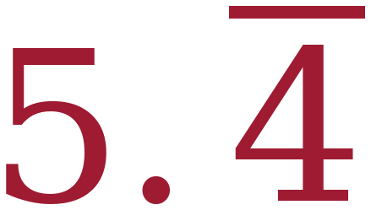  4/9 = 0.444…, and the whole number 5 comes along unchanged.
9. 7/9 | 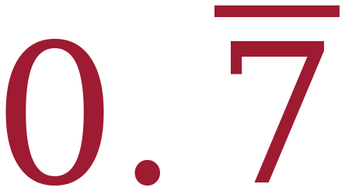  The numerator is the repeating digit.
10a. 101/9 as a mixed number | 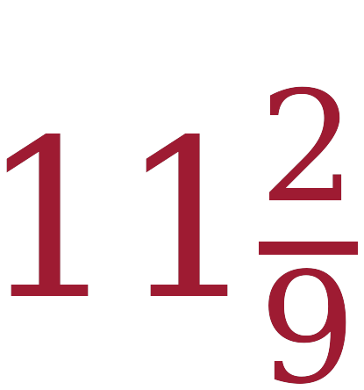  101 ÷ 9 = 11 with a remainder of 2.
10b. 101/9 as a decimal | 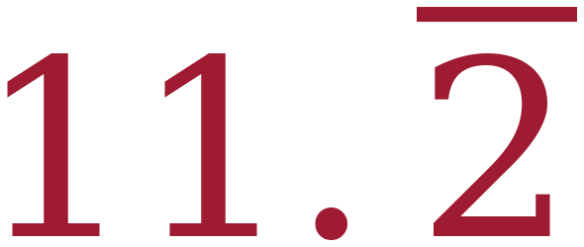  The ninths pattern gives 2/9 = 0.222…, so the answer is 11.222…
11a. terminating or repeating | Repeating.  5/9 = 0.5555… and it never stops.
11b. bar notation | 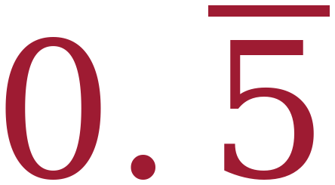
11c. why the last digit is a 6 | The calculator has room for only ten digits, so it rounds the last one it shows. The true value is 0.5555… and it never stops, so the 6 on the screen is the calculator rounding, not part of the pattern.  Accept any answer that says the calculator ran out of room and rounded. Do NOT accept “the calculator is wrong.”

Questions 1 and 2 hinge on one word. Math Nation's originals read “In order to rewrite a fraction as a decimal, …” and offered four strategies, two of which work. Their own Refresher teaches both and says outright that both are correct, so a student who learned the Refresher was marked wrong on the strength of it. Adding always makes exactly one option correct and turns the item into something worth asking — the equivalent-fraction method fails precisely on the denominators this unit is about.
Question 10 is the second of the two to circulate for. Question 6 is the other, and the slide-28 note names both. The mixed-number step is not optional: 101/9 means nothing to the ninths pattern until it is 11 2/9. Students who try to predict straight from 101/9 stall, and the stall is the lesson.
Question 11 is the one to read tonight. A student who says the calculator rounded has it. A student who says the calculator is wrong does not, and that is a different conversation — the machine is not faulty, it is finite. The same distinction returns in Unit 2, where π on the screen is also not what π is.
Additional Practice 7A.01.01 — Answer Key
Post this in Google Classroom alongside the practice sheet. It is optional work for students who want more.
1. | Divide the numerator by the denominator.
2. | Use the place value of the last digit to determine the denominator.
3. 27/8 | 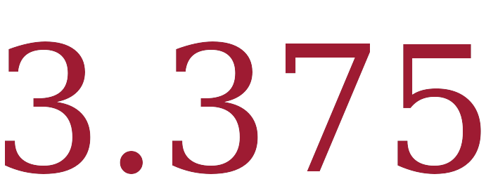 terminating  27 ÷ 8 = 3.375 exactly.
4. 6/11 | 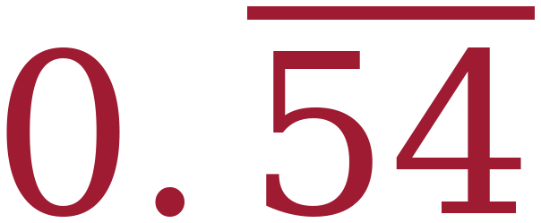 repeating  6 ÷ 11 = 0.545454… Both digits repeat.
5. 4/5 | 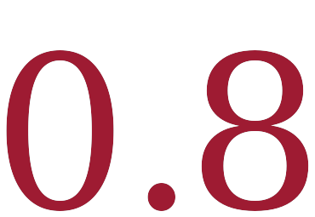 terminating  4 ÷ 5 = 0.8 exactly.
6. bar notation | B. 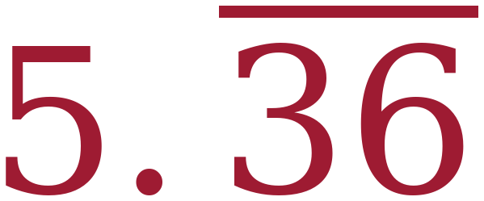  59/11 = 5.363636…, so the bar covers both digits. C would be 5.36666…
7. 5/11 | 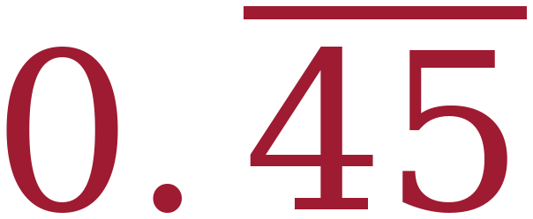  5 ÷ 11 = 0.454545…
8. 2 5/11 | 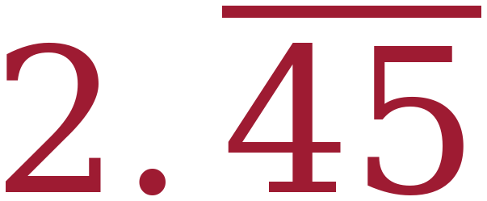
9. 10/11 | 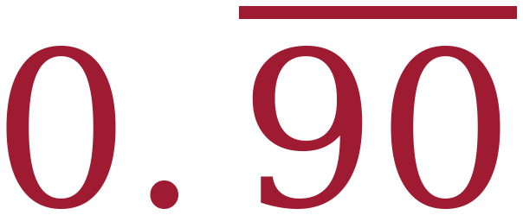  The bar covers 90. Students often drop the zero.
10a. 87/11 as a mixed number | 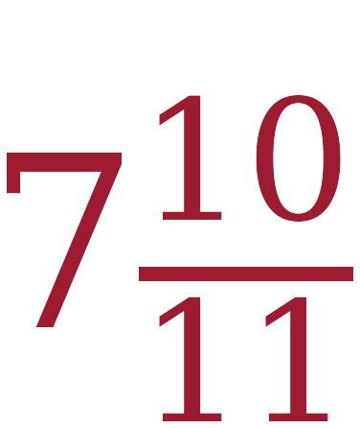  87 ÷ 11 = 7 with a remainder of 10.
10b. 87/11 as a decimal | 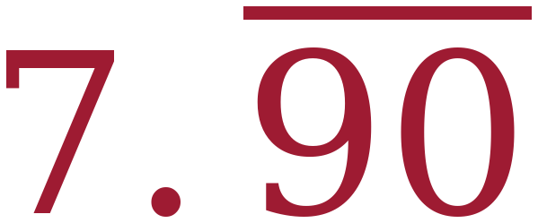
11a. | Repeating.
11b. bar notation | 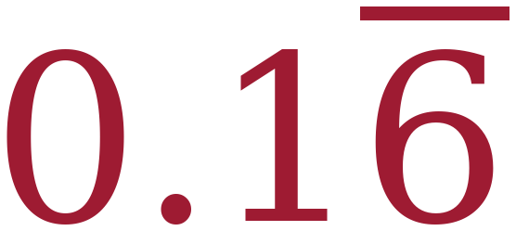  Only the 6 repeats.
11c. why the last digit is a 7 | The calculator has room for only ten digits, so it rounds the last one. The true value is 0.1666… and it never stops.
Misconceptions to Watch
- Not distinguishing terminating, repeating and rounded decimals. The headline error of this lesson, and the reason slides 13–15 exists. 0.555555556 on a screen is a rounded decimal, not a terminating one. (Florida B1G-M)
- Truncating a repeating decimal. Writing 5/9 as 0.55 or 0.555 and calling it done. (Florida B1G-M)
- Using the remainder as the decimal. 17 ÷ 8 read as “2 remainder 1” and written 2.1 instead of 2.125. (Florida B1G-M)
- Forgetting the bar. Named in Math Nation's own list for this lesson. No bar and no ellipsis means a terminating decimal, which is a different number. (Math Nation TE)
- Confusion when the calculator rounds the last digit. Also named in their list — which is why their soft “consider a discussion” is not enough on TI-30XAs. (Math Nation TE)
- Not remembering how to rewrite rational numbers in equivalent forms. Sixth-grade content. The Refresher work now sits inside Notes I and Example 1. (Math Nation TE)
- Judging a denominator before simplifying. 6/15 looks like it should repeat and does not, because it is 2/5. Notes III item A.
- Barring digits that do not repeat. Writing 2.1666… as 2.16 with a bar over both digits. Worksheet question 6 and the whiteboard sequence.
Changes from the Math Nation Lesson
- Every partner and group activity is replaced. There were eight: the Refresher matching activity, the Guided Instruction pattern discussion, three Exploration prompts, and Think-Pair-Share named three times in the teacher notes. The Exploration is now Example 2, worked individually with results pooled at the board, and the discussion prompts are the whiteboard sequence.
- The Warm-Up was replaced.The new warm-up asks students to predict which of five fractions never stop, which is the lesson's own question.
- The Wrap-Up was replaced. Their four-quadrant Interesting / Confusing / Makes Sense / Uninteresting plot produces no mathematical evidence. The Ticket Out the Door is three graded questions that tell you who is ready for Lesson 2.
- A full example was added for the calculator's rounding (slides 13–15), and a worksheet question to match it (question 11). Math Nation flags the issue twice but only as a Teacher Tip saying “consider a discussion.” On a TI-30XA, 5/9 and 6/9 both display a rounded final digit — two of the six rows in their own ninths table visibly contradict the pattern the table is designed to reveal.
- “Ellipse” was corrected to “ellipsis” throughout, in the glossary and in the instruction that tells students to use one.
- Worksheet questions 1 and 2 now ask which strategy ALWAYS works. As printed, question 1 had two correct answers, and the lesson's own Refresher taught both of them and stated that both work.
- Worksheet question 10 was rebuilt. As printed it read “101/9 = [blank] = ______” where the middle was a floating drawing of two empty rectangles rather than text — it moved and printed as dashed boxes, and nothing told the student the middle step was a mixed number. It is now parts (a) and (b) with the mixed number asked for by name. The Additional Practice question 10 had the same fault with 87/11 and got the same fix.
- Worksheet question 5 was changed from 42/9 to 14/3. Same value, same repeating decimal, but 42/9 was the only fraction in the set not in lowest terms — and the conjecture this lesson is building is about denominators after simplifying.
- Three wording errors were fixed in both sheets: “write each fraction in as an equivalent decimal” (stray word), “use the place value of the last digit determine the denominator” (missing “to,” four times per sheet), and “use your decimal equivalent found in question 7 for questions 7-10,” which should read 8 through 10.
- The Additional Practice stem “5.3636..” had a two-dot ellipsis. Corrected.
- The Guided Instruction answer “it is not possible because the remainder in the dividend always repeats” was rewritten. Remainders do not occur in the dividend. The reason a repeating decimal cannot terminate is that only finitely many remainders are possible, so one must eventually recur, and from there the quotient digits cycle forever. That explanation is now the board work on slide 6.
- Notes IV item C lists the denominators that repeated today rather than stating a rule. Math Nation deliberately holds the general rule for Lesson 2, and their teacher's edition says a rule that always works is not expected today. Their phrasing of the conjecture — “a 3, 9, or 11 in the denominator” — reads as the digit rather than the factor, so students apply it to 13 and 30; the slide lists only what was actually seen and says so on the slide.
- Answer keys were built for both the worksheet and the Additional Practice, from the same source file as the student versions, so the two cannot drift apart.
- Nothing in the mathematics was changed.

